| **Date** | **31 OCTOBER 2025** |
| --- | --- |
| **Team ID** | **NM2025TMID00034** |
| **Project Name** | **Laptop Request Catalog Item.** |
| **Maximum Marks** | **4 Marks** |

### Project Design Phase

## Solution Architecture

### Solution Architecture:

**Goals of the Architecture:**

* Provide a standardized, user-friendly self-service channel for all laptop requests.
* Automate the multi-stage approval workflow to enforce consistency and accountability.
* Ensure every request is tracked and automatically linked to the IT Asset Management (CMDB) system.
* Reduce manual processing time and eliminate email-based requests.

**Key Components:**

* **Service Catalog** (The user-facing portal and form interface).
* **Request Item (RITM)** and Catalog Tasks (The record types used for tracking and fulfillment).
* **Workflow Engine** (Logic for automated approvals and task generation).
* **Manager/User Data Tables** (Source for routing approval requests and user details).
* **IT Asset/Configuration Management Database (CMDB)** (The final destination for asset tracking).

**Development Phases:**

1. Define standard laptop models and specifications.
2. Build the Service Catalog Item and Request Form (variables).
3. Design and implement the automated approval workflow (Manager $\rightarrow$ Fulfillment).
4. Configure automated email notifications for the user and fulfillment teams.
5. Integrate the final fulfillment task with asset creation/update logic in the CMDB.
6. Perform comprehensive end-to-end user acceptance testing (UAT).

### Solution Architecture Description:

The solution architecture is centered around creating a transparent and fully automated hardware procurement process. The core component is a new item within the **Service Catalog**, which provides a single, standardized entry point for employees to request a laptop.

When a user submits the request, a **Request Item (RITM)** is created, triggering a robust **Workflow Engine**. This workflow is designed to ensure compliance: it automatically routes an approval request to the user's **Manager** for budget sign-off. Once approved, the workflow generates a series of **Catalog Tasks** for the **IT Hardware Fulfillment Team**.

Crucially, the final task in the fulfillment process includes an automated step to create a new record or update an existing one in the **IT Asset Management/CMDB** table. This integration ensures that every laptop procured through this process is instantly and accurately tracked in the system, maintaining data consistency and promoting operational accountability for IT assets.

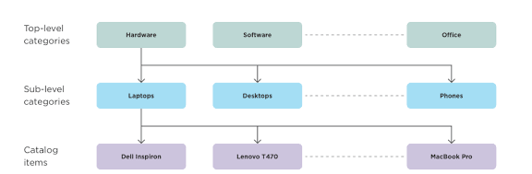Example – Solution Architecture Diagram: